**Microsoft .NET Framework using C#**

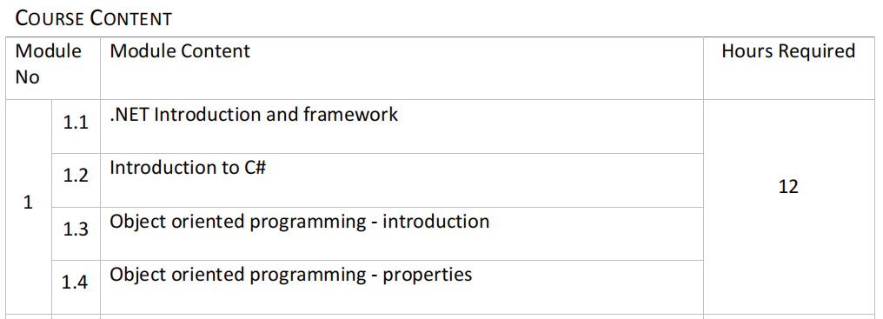

1. **.NET Introduction and framework** :

* It is a comprehensive software development platform developed by Microsoft.
* It is a virtual machine that provide a common platform to run an application that was built using the different language such as C#, VB.NET, Visual Basic, etc.
* Also used to create a **form based**, **console-based**, **mobile and web-based application** or services that are available in Microsoft environment.
* The main objective of this framework is to develop an application that can run on the windows platform.

### KEY Components of .NET Framework:

1. **Common Language Runtime (CLR):**Manages the execution of .NET programs, providing services such as memory management, security, and exception handling.
2. **.NET Framework Class Library (FCL):** A vast collection of reusable classes, interfaces, and value types.

**KEY Features**:

1. **Multiple Language Support.**
2. **Cross-Platform Development.**
3. **Versatile Application Development:**A vast collection of reusable classes, interfaces, and value types.

**KEY Advantages** :

1. **Security.**
2. **Performance.**
3. **Integration.**